NEPAL COLLEGE OF INFORMATION TECHNOLOGY
Balkumari, Lalitpur
Affiliated to Pokhara University

LAB REPORT FOR DATABASE MANAGEMENT SYSTEM


LAB REPORT 10: JOINS AND DATA MANIPULATION

Submitted by: Submitted to:
Name: Arpan Adhikari Er. Simanta Kasaju
Roll No.: 231309
BE-CE (3rd SEM)

S. N | LAB TOPIC | DATE | REMARKS
1. | INTRODUCTION TO SQL | 10th Nov
2. | FAMILIARIZATION WITH DDL COMMAND | 17th Nov
3. | FAMILIARIZATION WITH VARIOUS CONSTRAINTS IN SQL | 24th Nov
4. | FAMILIARIZATION WITH DML COMMANDS (INSERT, UPDATE, DELETE) | 1st Dec
5. | FAMILIARIZATION WITH DCL COMMANDS (GRANT, REVOKE) | 8th Dec
6,7. | FAMILIARIZATION WITH TCL COMMAND AND DQL COMMANDS | 15th Dec
8. | FAMILIARIZATION WITH SOME CLAUSES (SELECT, FROM, WHERE, GROUP BY, HAVING, ORDER BY,BETWEEN, NOT BETWEEN), ALIAS OPERATION (AS OPERATOR), CASE, NESTED QUERY COMMANDS (IN, NOT IN, HAVING, ALL, ANY, EXIST), Union. | 22nd Dec
9. | FAMILIARIZATION WITH AGGRIGATE FUNCTION AND AGGRIGATE FUNCTION WITH GROUP BY AND HAVING | 29th Dec
10. | JOINS AND DATA MANIPULATION | 19th Jan

THEORY:6666666666Joins and Data Manipulation in Relational Databases:
Relational databases store and organize data in multiple tables to minimize redundancy and maintain data integrity. To retrieve and manipulate this data efficiently, two key concepts are used: joins and data manipulation. This document elaborates on these concepts in detail.
Joins
Joins are SQL operations that allow combining rows from two or more tables based on a related column. Joins are essential for retrieving data spread across multiple tables in a relational database. There are different types of joins, each serving specific use cases:
- Inner Join
An inner join retrieves records that have matching values in both tables. It excludes rows where the join condition is not satisfied.
Syntax:
SELECT column_names
FROM table1
INNER JOIN table2
ON table1.column_name = table2.column_name;
- Left Join (or Left Outer Join)
A left join retrieves all records from the left table and the matching records from the right table. If no match exists, NULL is returned for columns from the right table.
Syntax:
SELECT column_names
FROM table1
LEFT JOIN table2
ON table1.column_name = table2.column_name;
- Right Join (or Right Outer Join)
A right join retrieves all records from the right table and the matching records from the left table. If no match exists, NULL is returned for columns from the left table.
Syntax:
SELECT column_names
FROM table1
RIGHT JOIN table2
ON table1.column_name = table2.column_name;
- Full Join (or Full Outer Join)
A full join retrieves all records where there is a match in either table. It combines the results of both left and right joins. Rows with no match in one table will have NULL in columns from that table.
Syntax:
SELECT column_names
FROM table1
FULL OUTER JOIN table2
ON table1.column_name = table2.column_name;
- Cross Join
A cross join produces a Cartesian product of two tables, combining every row of the first table with every row of the second table.
Syntax:
SELECT column_names
FROM table1
CROSS JOIN table2;
- Self Join
A self join joins a table with itself. It is useful when the table contains hierarchical data, such as an employee reporting to a manager.
Syntax:
SELECT a.column_name, b.column_name
FROM table_name a, table_name b
WHERE a.common_column = b.common_column;
Data Manipulation
Data manipulation involves performing operations like inserting, updating, deleting, and retrieving data from database tables. These operations are part of the SQL Data Manipulation Language (DML).
- Insert
The insert operation adds new rows to a table.
Syntax:
INSERT INTO table_name (column1, column2, ...)
VALUES (value1, value2, ...);
- Update
The update operation modifies existing records in a table based on a specified condition.
Syntax:
UPDATE table_name
SET column1 = value1, column2 = value2, ...
WHERE condition;
- Delete
The delete operation removes records from a table based on a condition.
Syntax:
DELETE FROM table_name
WHERE condition;
- Select
The select operation retrieves data from one or more tables. It allows filtering, sorting, and aggregation of data.
Syntax:
SELECT column_names
FROM table_name
WHERE condition;
Advanced Data Manipulation Techniques
- Aggregate Functions
SQL provides aggregate functions like COUNT, SUM, AVG, MAX, and MIN to perform calculations on a set of values and return a single value. For example:
SELECT COUNT(*) FROM table_name;
- Group By
The group by clause groups rows with the same values into summary rows. It is often used with aggregate functions.
Syntax:
SELECT column_name, aggregate_function(column_name)
FROM table_name
GROUP BY column_name;
- Having
The having clause is used to filter grouped data. It is similar to the where clause but applies to groups.
Syntax:
SELECT column_name, aggregate_function(column_name)
FROM table_name
GROUP BY column_name
HAVING condition;
- Subqueries
Subqueries are nested queries that allow using the result of one query as input for another query. For example:
SELECT column_name
FROM table_name
WHERE column_name = (SELECT MAX(column_name) FROM another_table);
- Transactions
Transactions allow grouping multiple SQL statements into a single unit of work. They ensure data integrity through the ACID properties (Atomicity, Consistency, Isolation, Durability).
Syntax:
BEGIN TRANSACTION;
-- SQL statements
COMMIT;
or
ROLLBACK;
Understanding joins and data manipulation is essential for effectively working with relational databases. These concepts enable users to handle complex data relationships, perform calculations, and manage database content with precision and efficiency.

Question 10.1:

Question 1: Perform all kinds of join

- Inner Join: Retrieves all rows where there is a match in both tables.

SELECT * FROM student
INNER JOIN result ON student.Sid = result.Sid;

- Left Join: Retrieves all rows from the left table (student) and matching rows from the right table (result). If there's no match in the right table, NULL values are returned.

SELECT *FROM student
LEFT JOIN result ON student.Sid = result.Sid;

- Right Join: Retrieves all rows from the right table (result) and matching rows from the left table (student). If there's no match in the left table, NULL values are returned.

SELECT *FROM student
RIGHT JOIN result ON student.Sid = result.Sid;
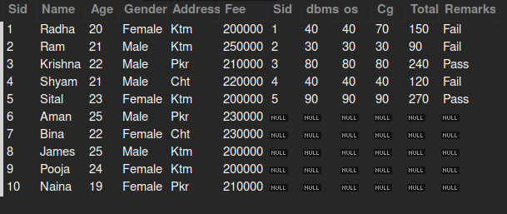

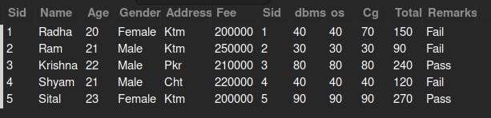

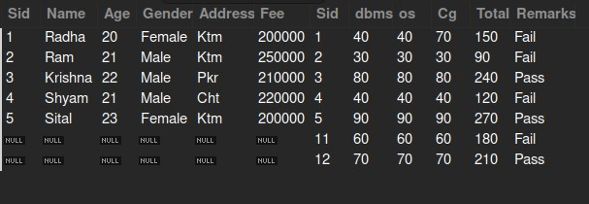

Question 2: Find the result of Radha.
SELECT student.*, result.* FROM student
INNER JOIN result ON student.Sid = result.Sid WHERE student.Name = 'Radha';

Question 3: Check whether the Shyam is a fail or a pass.
SELECT student.Name, result.Remarks FROM student
INNER JOIN result ON student.Sid = result.Sid
WHERE student.Name = 'Shyam';


Question 4: What is the total of marks who is from ktm and name sital.
SELECT student.Name, SUM(result.Total) AS TotalMarks FROM student
INNER JOIN result ON student.Sid = result.Sid
WHERE student.Name = 'Sital' AND student.Address = 'Ktm';


Question 5: Find all the information of the result whose name starts and ends with s.
SELECT student.*, result.* FROM student
INNER JOIN result ON student.Sid = result.Sid WHERE student.Name LIKE 'S%s';

-- No rows affected

Question 6: What is the total of marks whose fee is >200000
SELECT student.Name, SUM(result.Total) AS TotalMarks FROM student
INNER JOIN result ON student.Sid = result.Sid WHERE student.Fee > 200000;



Question 7: Find the os and cg marks of a student who is 20 years old and belongs to ktm.
SELECT student.Name, result.os, result.Cg FROM student
INNER JOIN result ON student.Sid = result.Sid
WHERE student.Age = 20 AND student.Address = 'Ktm';
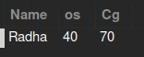

Question 8: Display the names of students who passed.
SELECT student.Name FROM student
INNER JOIN result ON student.Sid = result.Sid WHERE result.Remarks = 'Pass';

Question 9: Display only male students who passed.
SELECT student.Name ,result.remarks,student.gender FROM student
INNER JOIN result ON student.Sid = result.Sid WHERE result.Remarks = 'Pass' AND student.Gender = 'Male';

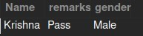

Question 10: What are the highest marks on dbms scored by females?
SELECT student.Name,student.Gender, MAX(result.dbms) AS MaxDBMSMarks FROM student
INNER JOIN result ON student.Sid = result.Sid WHERE student.Gender = 'Female';
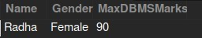

Question 11: What are the highest total marks gender-wise?
SELECT student.Gender, MAX(result.Total) AS MaxTotalMarks FROM student
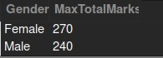
INNER JOIN result ON student.Sid = result.Sid GROUP BY student.Gende
Question 12: How many students are thereafter performing natural join?
SELECT COUNT(*) AS TotalStudents FROM student
NATURAL JOIN result;
--Natural join retrieves all data joining both tables



Question 13: How many female students passed?
SELECT COUNT(*) AS FemalePassCount,student.Gender FROM student
INNER JOIN result ON student.Sid = result.Sid
WHERE result.Remarks = 'Pass' AND student.Gender = 'Female';



Question 14: Count the number of male and female students who passed.

SELECT student.Gender, COUNT(*) AS PassCount FROM student
INNER JOIN result ON student.Sid = result.Sid WHERE result.Remarks = 'Pass'
GROUP BY student.Gender;



Question 15: What is the number of pass and fail among boys?
SELECT result.Remarks, COUNT(*) AS CountMale
FROM student
INNER JOIN result ON student.Sid = result.Sid WHERE student.Gender = 'Male'
GROUP BY result.Remarks;

Question 16: Who are the older male students who are able to pass.
SELECT student.* FROM student
INNER JOIN result ON student.Sid = result.Sid
WHERE result.Remarks = 'Pass' AND student.Gender = 'Male' ORDER BY student.Age DESC
LIMIT 1;

Question 17: Order all the student and result information according to their total.
SELECT student.*, result.* FROM student
INNER JOIN result ON student.Sid = result.Sid ORDER BY result.Total DESC;
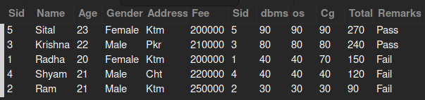

Question 18: Find the max marks on dbms address-wise.
SELECT student.Address, MAX(result.dbms) AS MaxDBMSMarks FROM student
INNER JOIN result ON student.Sid = result.Sid GROUP BY student.Address;


Question 19: Find the student's name and gender, whose age is greater than the marks in dbms.
SELECT student.Name, student.Gender FROM student
INNER JOIN result ON student.Sid = result.Sid WHERE student.Age > result.dbms;

-- no rows affected

Question 20: What is the age of the older person who are able to pass?
SELECT MAX(student.Age) AS OldestAge,result.remarks FROM student

INNER JOIN result ON student.Sid = result.Sid WHERE result.Remarks = 'Pass'

Question 21: What is the max fee among males who manage to pass?
SELECT student.Name,MAX(student.Fee) AS MaxFee FROM student
INNER JOIN result ON student.Sid = result.Sid
WHERE result.Remarks = 'Pass' AND student.Gender = 'Male';



Question 10.2:

Question 1: Update the address of a student who scored 70 in CG to Bhaktapur (Bkt).
UPDATE student JOIN result ON student.Sid = result.Sid
SET student.Address = 'Bkt' WHERE result.Cg = 70;

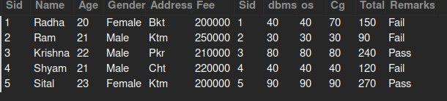

Question 2: Update the gender to 'Female' and name to 'Rita' for the student who scored 90 as total.
UPDATE student JOIN result ON student.Sid = result.Sid
SET student.Gender = 'Female', student.Name = 'Rita'
WHERE result.Total = 90;

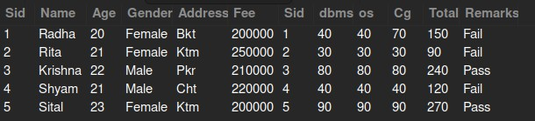

Question 3: Increase the fee by 20% for students who failed.

UPDATE student JOIN result
ON student.Sid = result.Sid
SET student.Fee = student.Fee * 1.2 WHERE result.Remarks = 'Fail';

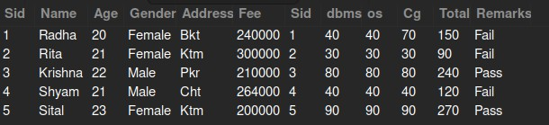

Question 4: Increase the fees by 20% for students who failed and decrease by 20% for students who passed.
-- Adjust fee based on pass/fail status
UPDATE student JOIN result ON student.Sid = result.Sid SET student.Fee = CASE
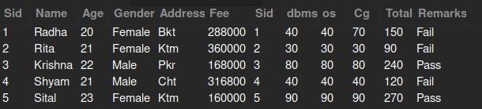
WHEN result.Remarks = 'Fail' THEN student.Fee * 1.2 WHEN result.Remarks = 'Pass' THEN student.Fee * 0.8 ELSE student.Fee END;
Question 5: Update the DBMS marks, os marks, and total of Shyam by 90,90,220 and also add remarks as pass.

UPDATE student JOIN result ON student.Sid = result.Sid
SET result.dbms = 90, result.os = 90, result.Total = 220, result.Remarks = 'Pass'
WHERE student.Name = 'Shyam';
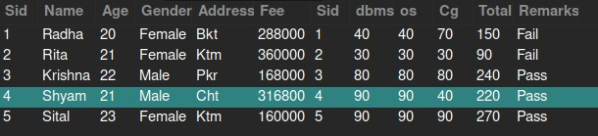

Question 6: Update the address of students to USA whose dbms marks is not provided.

UPDATE student left JOIN result ON student.Sid = result.Sid
SET student.Address = 'USA' WHERE result.dbms IS NULL;

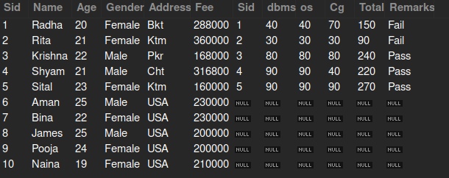

Question 7: Update the marks of dbms by 40 whose dbms marks is previously not provided and name is Naina.
UPDATE student LEFT JOIN result ON student.Sid = result.Sid
SET result.dbms = 40 WHERE student.Name = 'Naina' AND result.dbms IS NULL;

-- name with naina is not present in the table

Question 8: Add name, age, and address as Shila,24, Female to the students whose info was previously not provided but who score 210 and pass.

UPDATE student JOIN result ON student.Sid = result.Sid
SET student.Name = 'Shila', student.Age = 24, student.Gender = 'Female', student.Address = 'ktm'
WHERE result.Total = 210 AND result.Remarks = 'Pass' AND student.Sid NOT IN (SELECT Sid FROM student);

Question 9: Increase the total fee by 10% who are younger than 23 years old and score 90 as total.

UPDATE student JOIN result ON student.Sid = result.Sid
SET student.Fee = student.Fee * 1.1 WHERE student.Age < 23 AND result.Total = 90;

Question 10: Update the name as Rahul whose name is not provided and add dbms,os,cg,total as 50,50,50,150 whose scores are not provided.

UPDATE student JOIN result ON student.Sid = result.Sid
SET student.Name = 'Rahul', result.dbms = 50, result.os = 50, result.cg = 50, result.Total = 150
WHERE student.Name IS NULL AND result.dbms IS NULL;

-- no such row are present

Question 11: Update the total of Shyam who is from cht as null.

UPDATE student JOIN result ON student.Sid = result.Sid
SET result.Total = NULL WHERE student.Name = 'Shyam' AND student.Address = 'Cht';

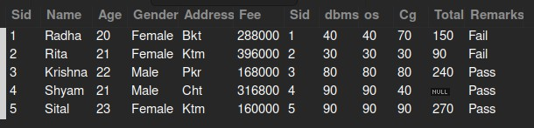

Question 12: Update all the marks as 60,60,60,180 whose name starts with ‘sh’.

UPDATE student JOIN result ON student.Sid = result.Sid
SET result.dbms = 60, result.os = 60, result.cg = 60, result.Total = 180 WHERE student.Name LIKE 'sh%';

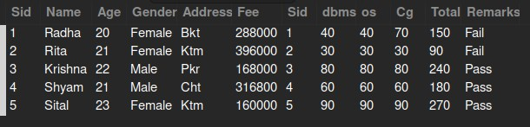

Question 13: Delete the information of females who are from ktm and score 40 in dbms.

DELETE FROM student USING student JOIN result ON student.Sid = result.Sid WHERE student.Gender = 'Female' AND student.Address = 'Ktm' AND result.dbms = 30;

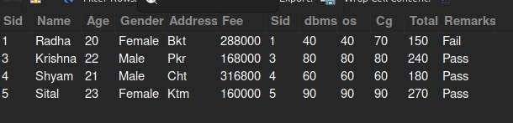

Question 14: Delete the info of the female who failed in exam and belongs to Bkt.

DELETE FROM student USING student JOIN result ON student.Sid = result.Sid
WHERE student.Gender = 'Female' AND student.Address = 'Bkt' AND result.Remarks = 'Fail';
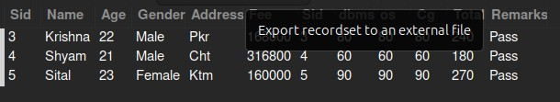

Question 15: Delete the info of students whose results are not provided.

DELETE FROM student USING student LEFT JOIN result ON student.Sid = result.Sid WHERE result.Sid IS NULL;
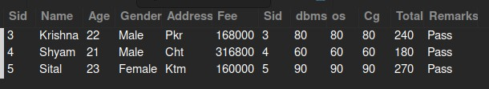

Question 16: Delete the info of results whose students info is not provided.

DELETE FROM result USING student RIGHT JOIN result on student.Sid = result.Sid WHERE student.Sid IS NULL;
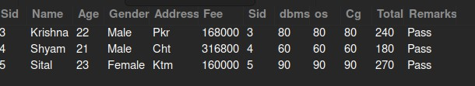

CONCLUSION:
In conclusion, joins and data manipulation are fundamental concepts in relational database management, playing a pivotal role in managing and interacting with structured data efficiently. Joins provide the framework for combining data from multiple tables, enabling a seamless representation of the relationships within a database. Whether it’s an inner join to fetch matching records, a left or right join to include unmatched rows, or a full join for comprehensive data analysis, each type of join addresses specific data requirements, enhancing the flexibility and power of SQL queries. Advanced joins like cross joins and self joins further broaden the scope of data retrieval, catering to complex scenarios such as hierarchical data representation and Cartesian product generation.
On the other hand, data manipulation enables dynamic interactions with database tables, empowering users to insert new records, update existing ones, delete obsolete data, and retrieve valuable information as needed. These operations ensure that databases remain functional, relevant, and up-to-date. Beyond the basics, advanced techniques like aggregate functions, grouping, subqueries, and transactions introduce layers of sophistication, allowing for efficient summarization, filtering, and transactional consistency. These tools enable users to derive meaningful insights, maintain data integrity, and handle multi-step operations with precision and reliability.
Together, joins and data manipulation form the backbone of modern database management, fostering an environment where complex data relationships can be represented and managed efficiently. They allow businesses, developers, and analysts to make informed decisions by providing mechanisms to query and transform data into actionable insights. Furthermore, mastering these concepts is crucial in today’s data-driven world, where the ability to handle vast amounts of interconnected data is a valuable skill.
As databases continue to evolve, the principles of joins and data manipulation remain timeless, underpinning advancements in big data, analytics, and artificial intelligence. They not only ensure the smooth functioning of relational databases but also lay the foundation for understanding more complex database paradigms. Ultimately, these concepts equip individuals with the tools to design robust databases, perform in-depth analyses, and optimize systems for better performance, scalability, and adaptability to the ever-changing demands of the digital age.

